PROJECT 1

Working with IAM roles with S3 and bootstrapping with EC2

Task 1: Creating a bootstrap instance

SS1:

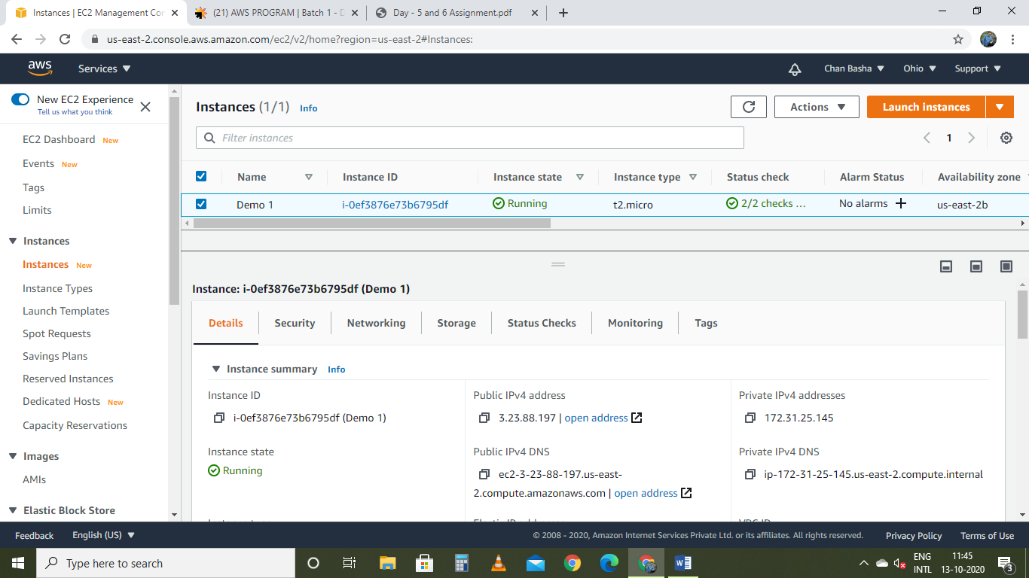

SS2: User data

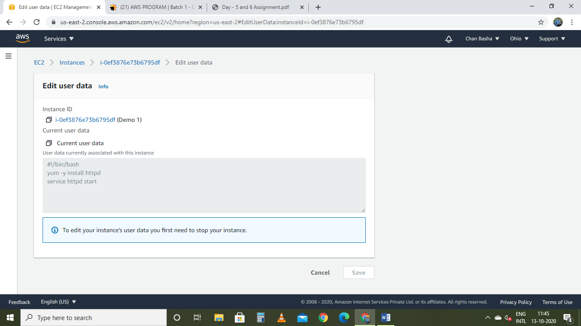

SS3: Test page

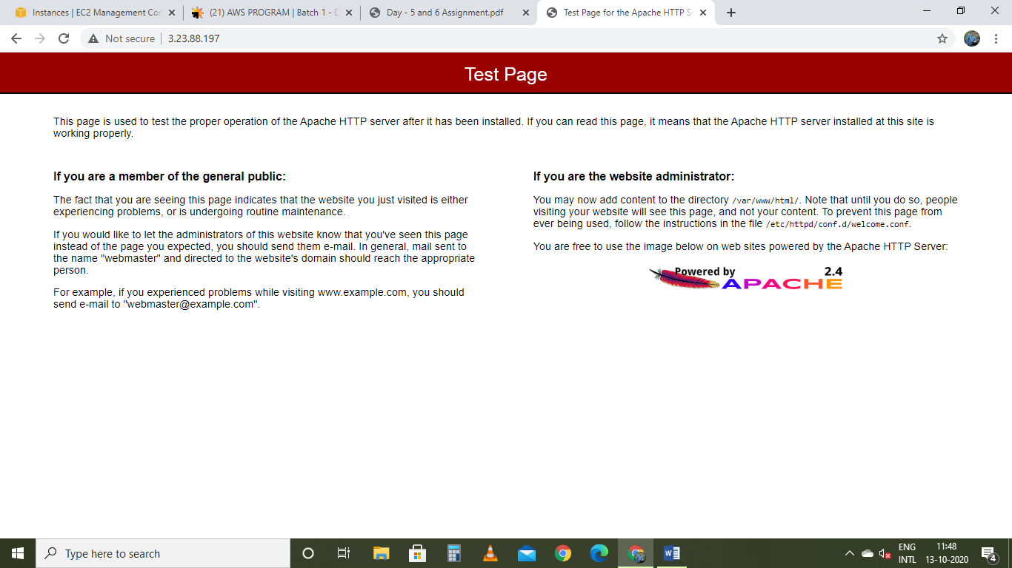

Task 2: Checking bucket list and creating a new bucket from EC2 using IAM Roles

SS1: creating S3 role access

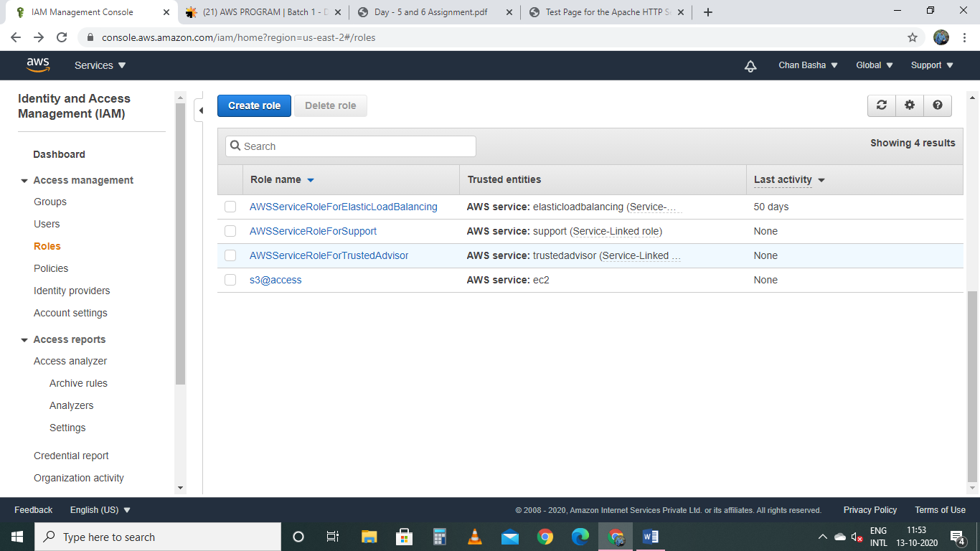

SS2:

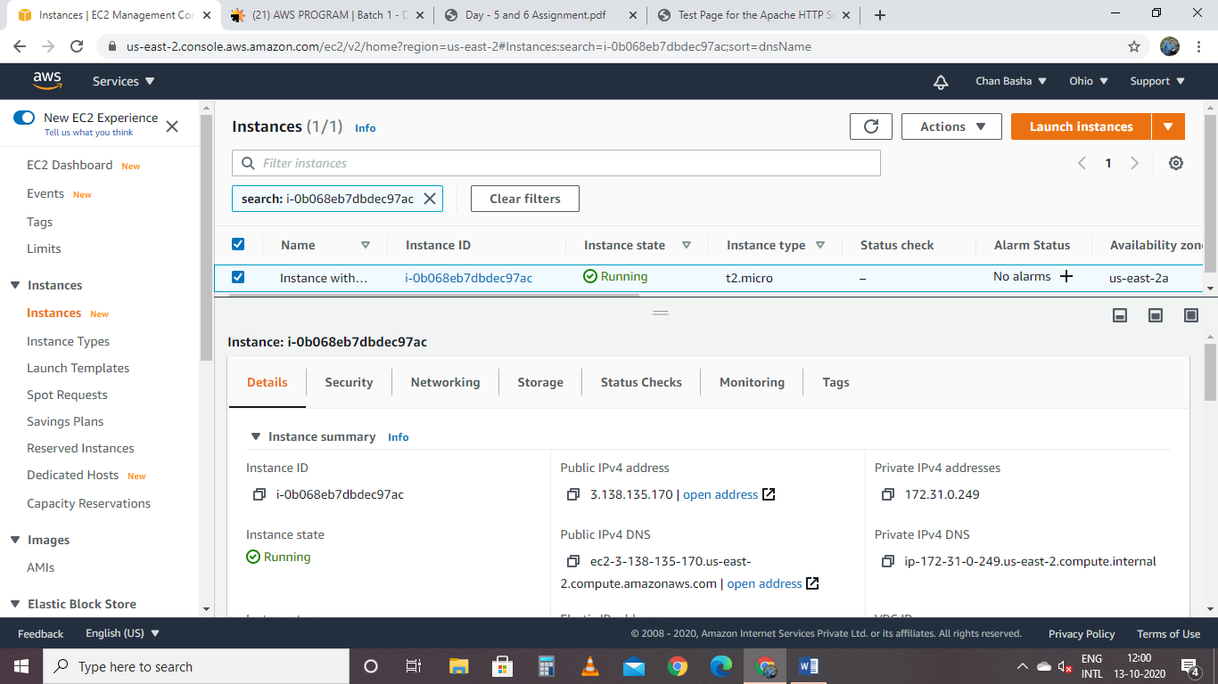

Insatnce with IAM role

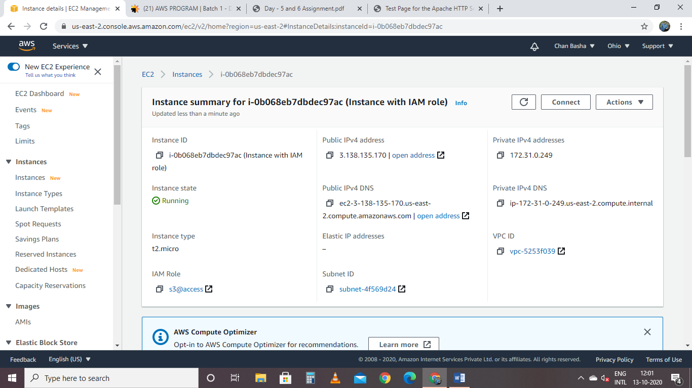

Command 1: aws s3 ls

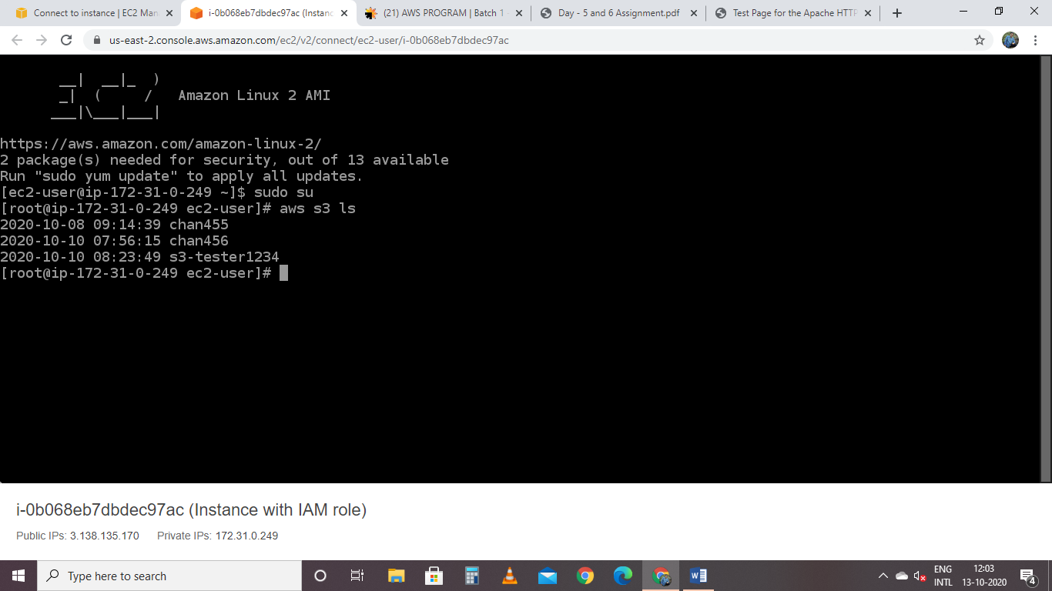

Creating a new bucket with command

aws s3 mb s3://bas55t5

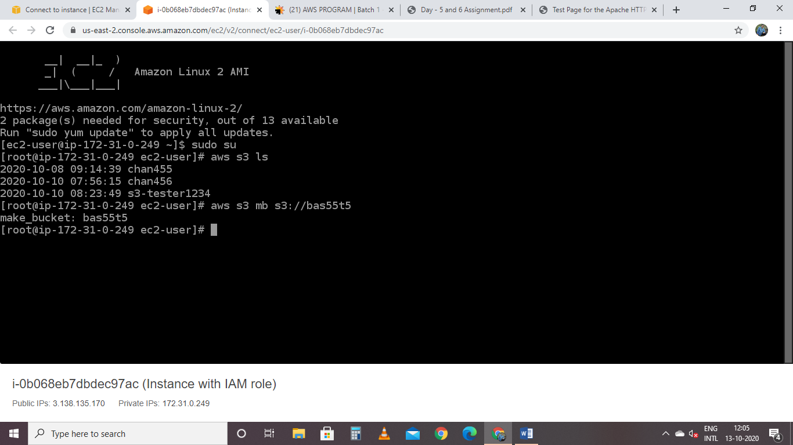

Removing bucket with command

aws s3 rb s3://bas55t5

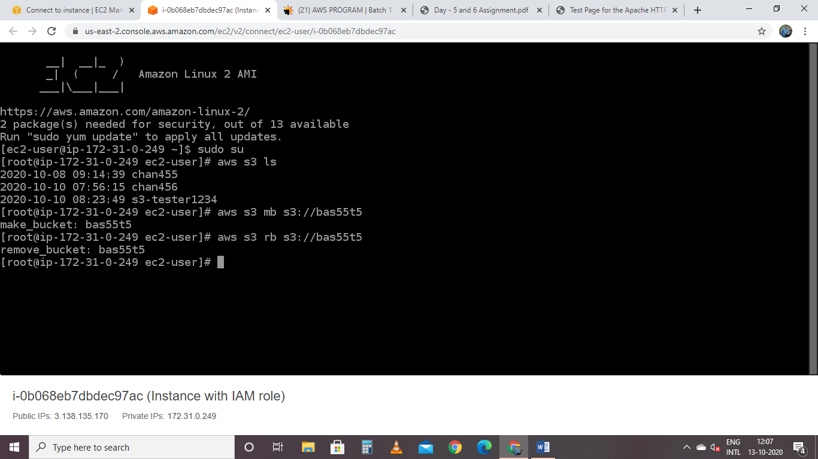

Task 3: Hosting a webpage using the bootstrap script on ec2.

SS1: uploading index.html file into bucket

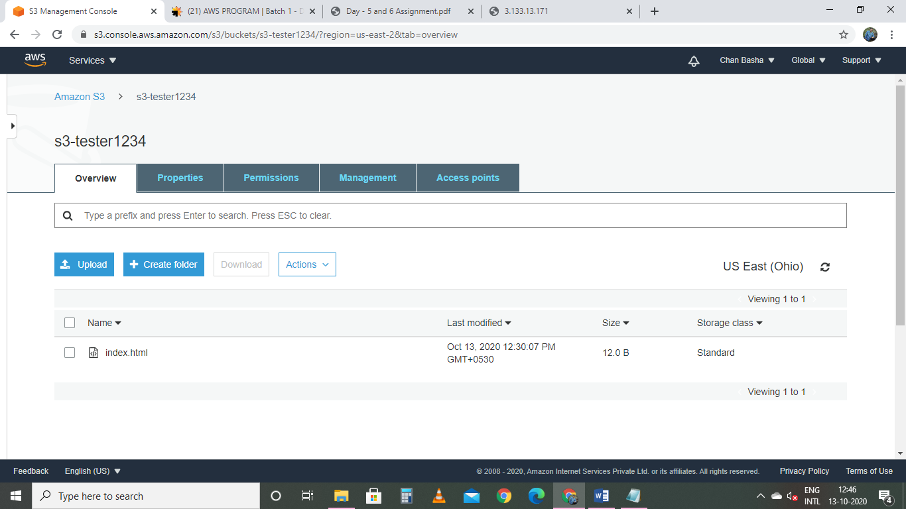

Ss2: list of instances

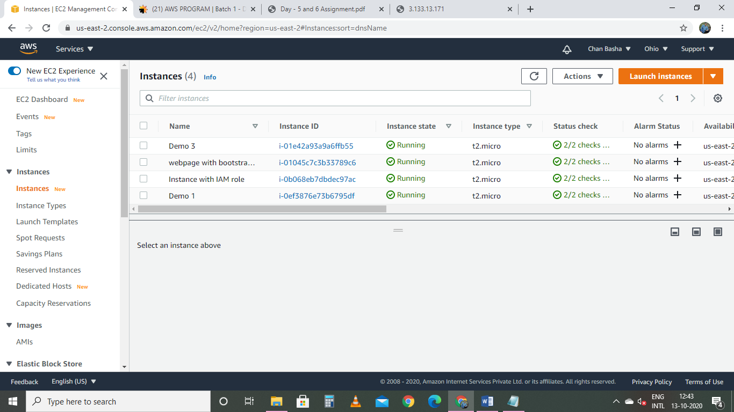

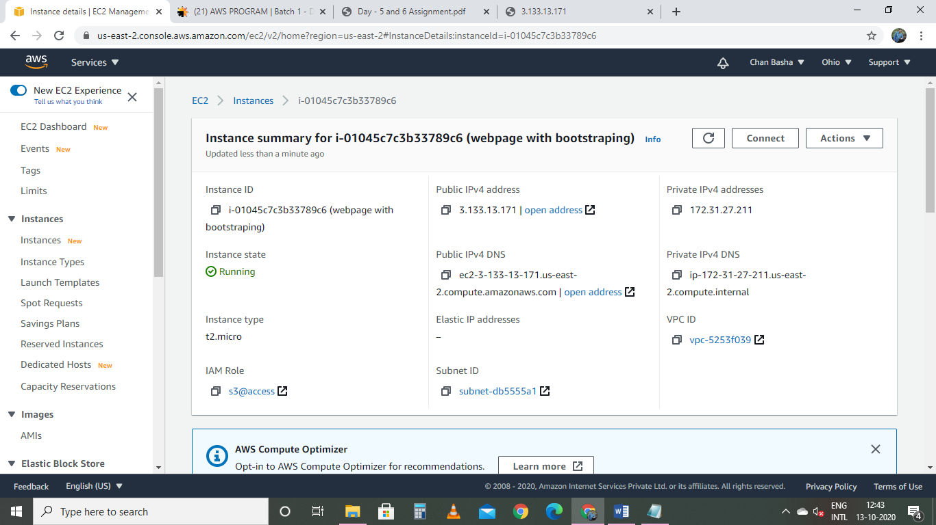

SS3: user data

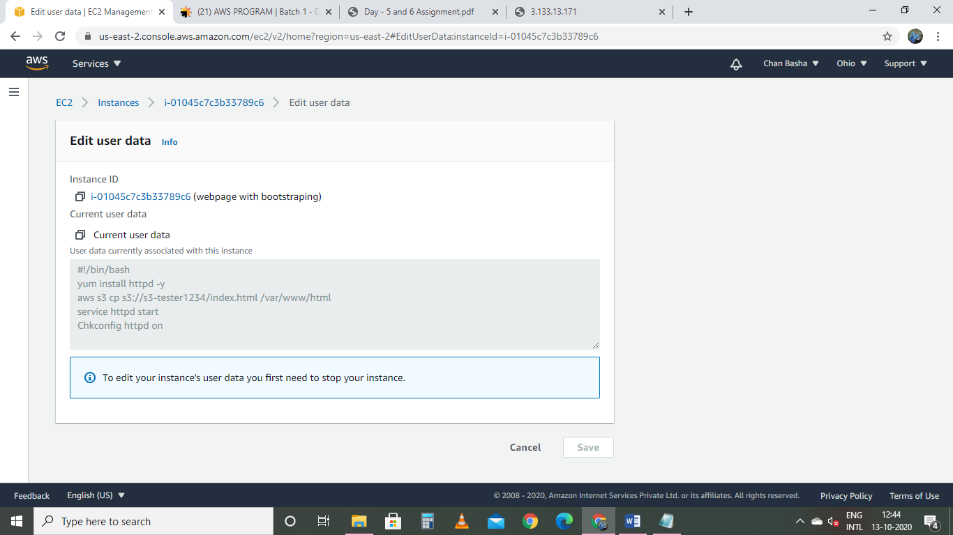

SS4:

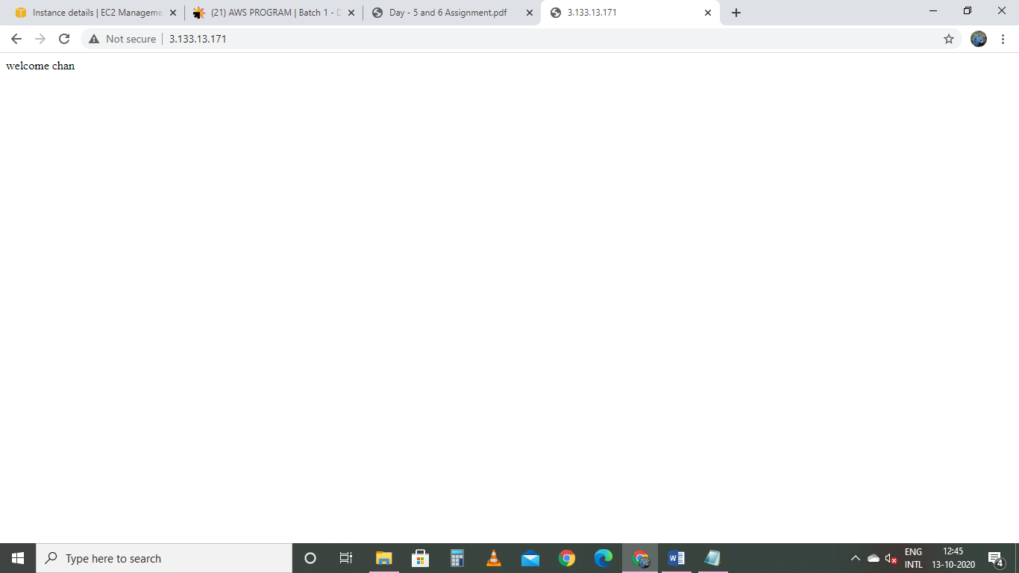

PROJECT 2

Creating an EC2 instance in Custom VPC

Task 1: Creating a VPC

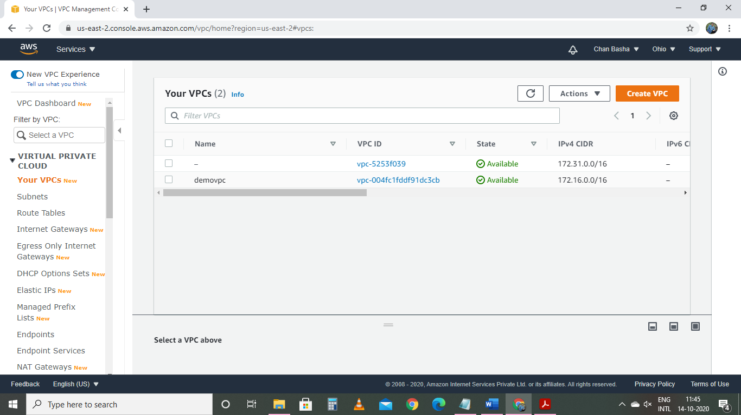

Task 2: Creating an Internet Gateway and attached to VPC

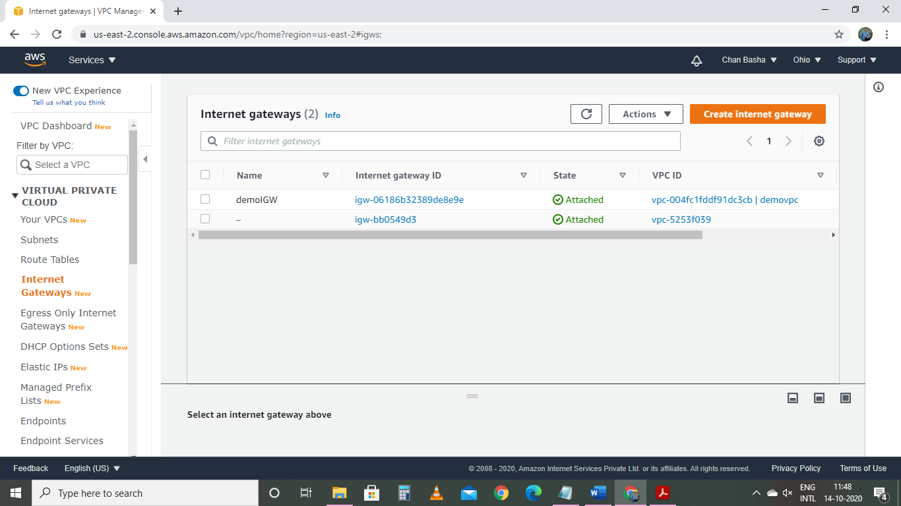

Task 3: creating a route table

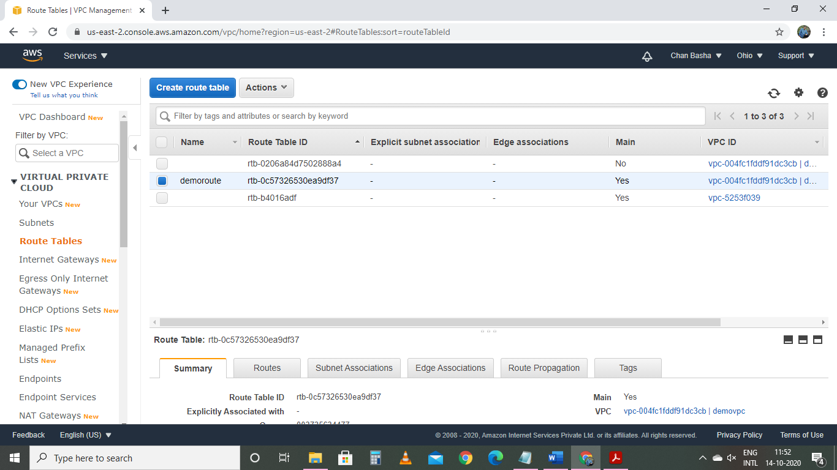

With routes attached

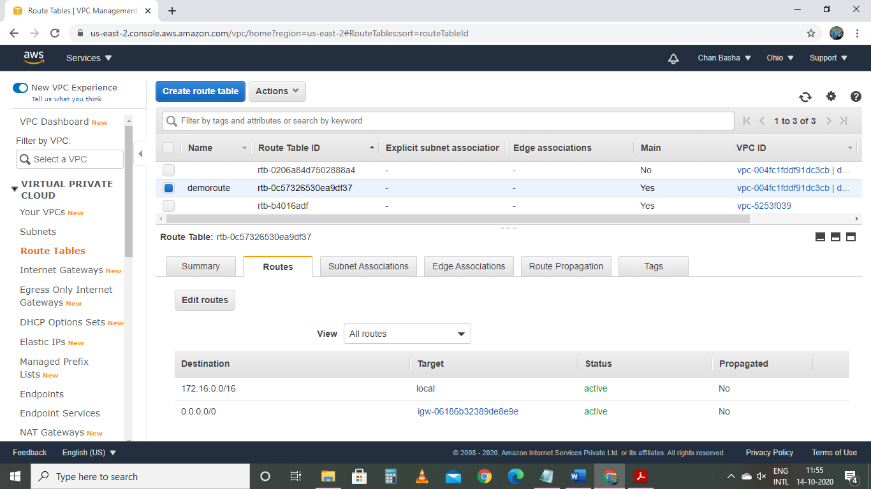

Task 4: creating a subnet

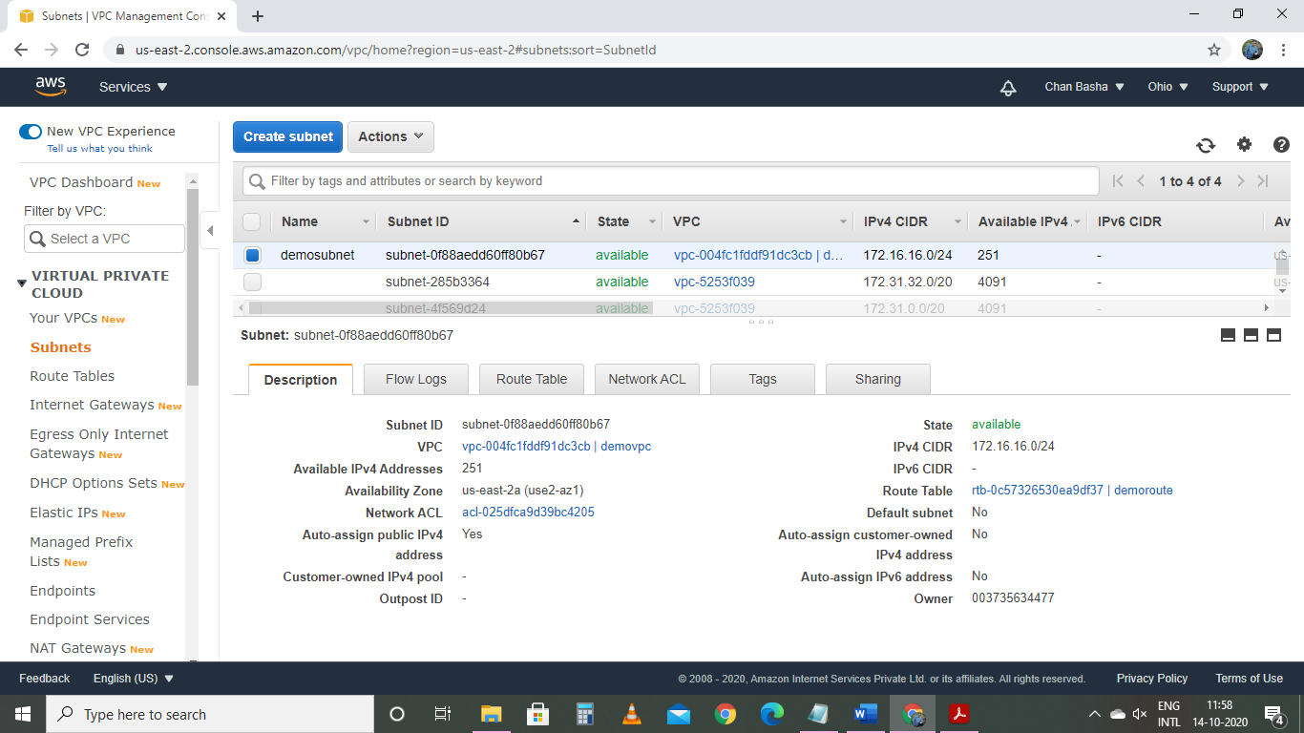

Task 5: creating EC2 instance in our own created VPC

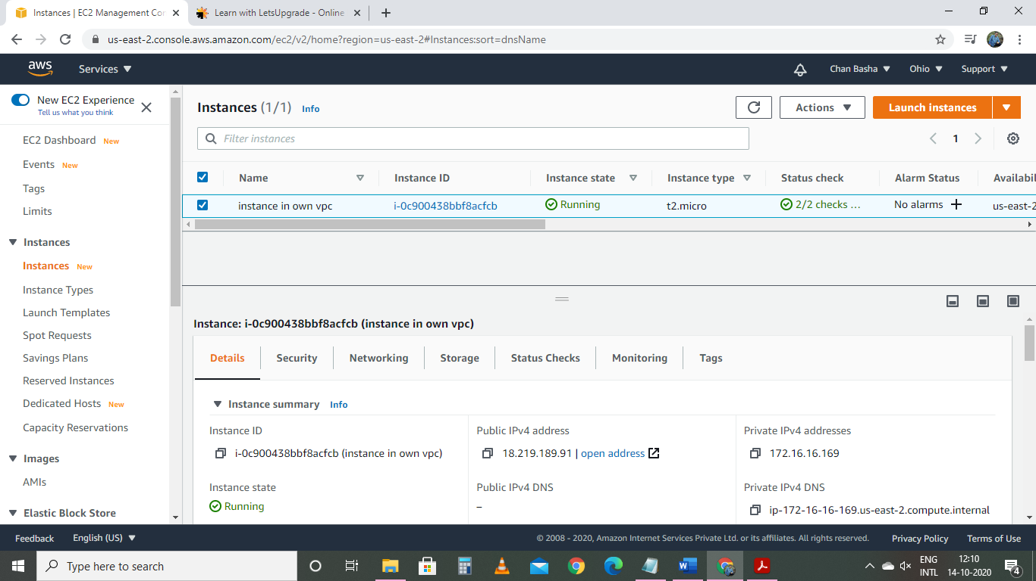

Task 6: checking ipconfig command in VM command prompt

